Week 4

1. 15 rows, 5 Columns

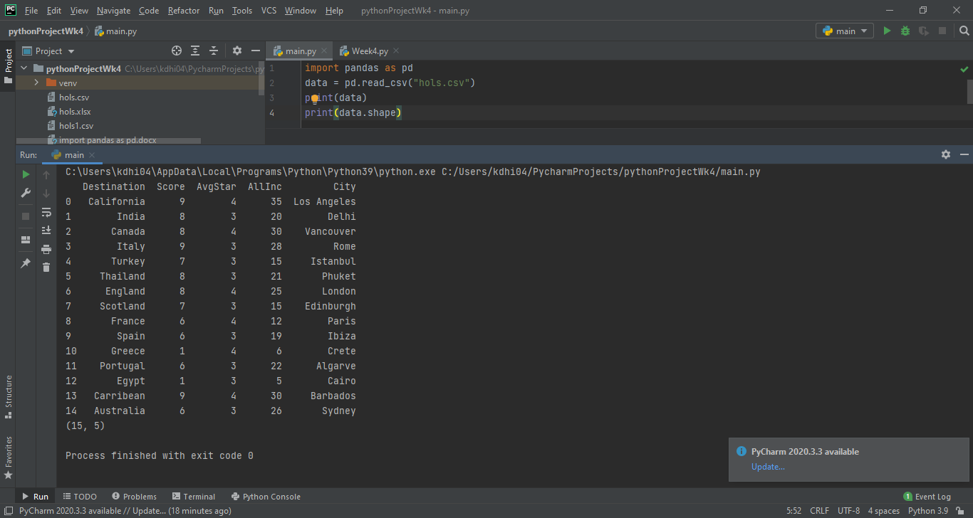

1. Print rows 3-8 :

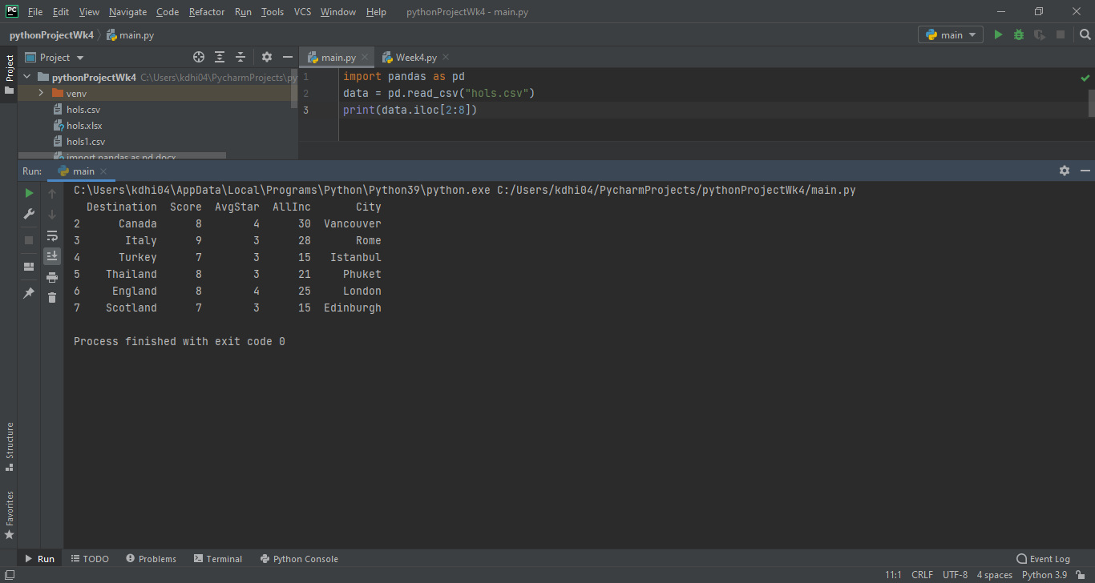

1. Mean number of all-inclusive hotels across all destinations = 20.6

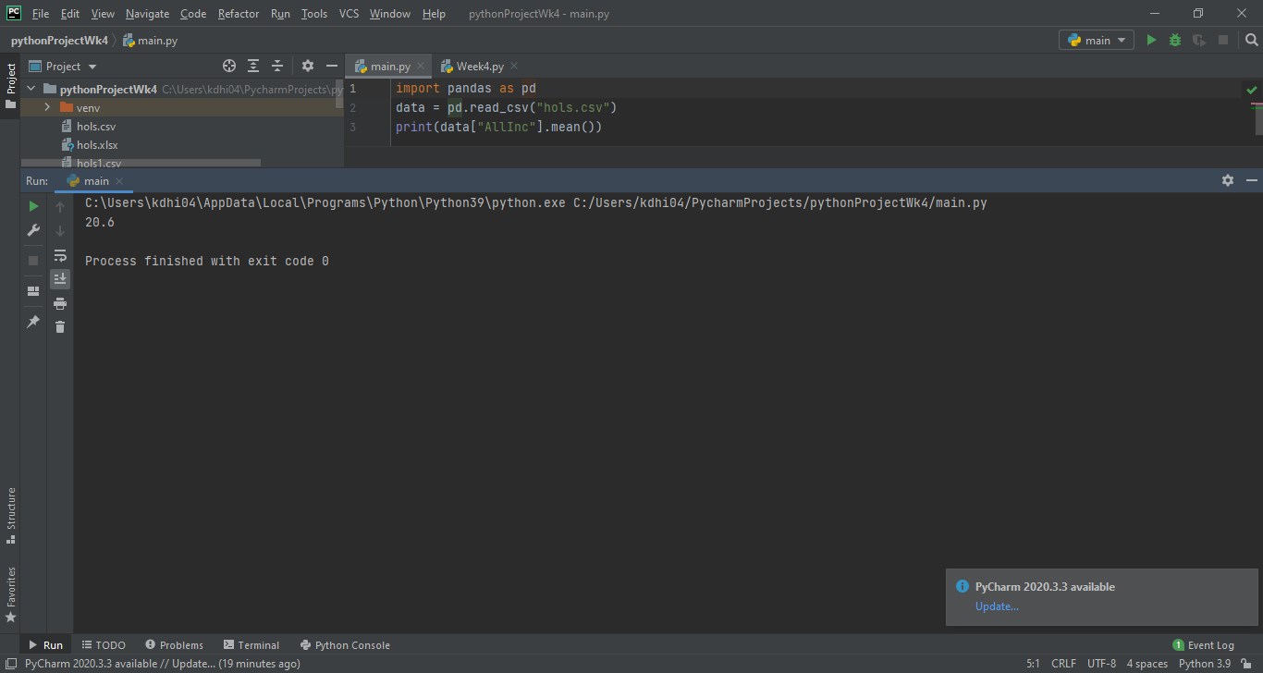

1. Lowest Scoring Destination

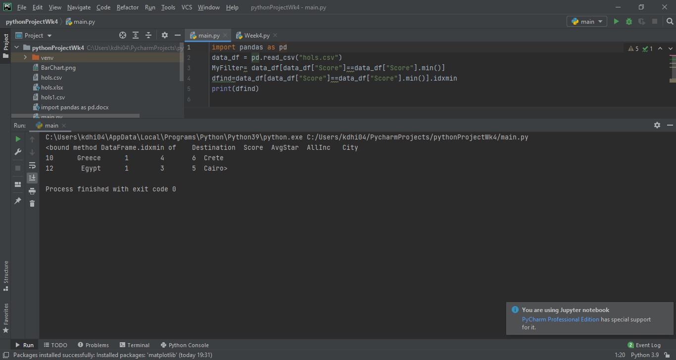

1. Highest Scoring Destination

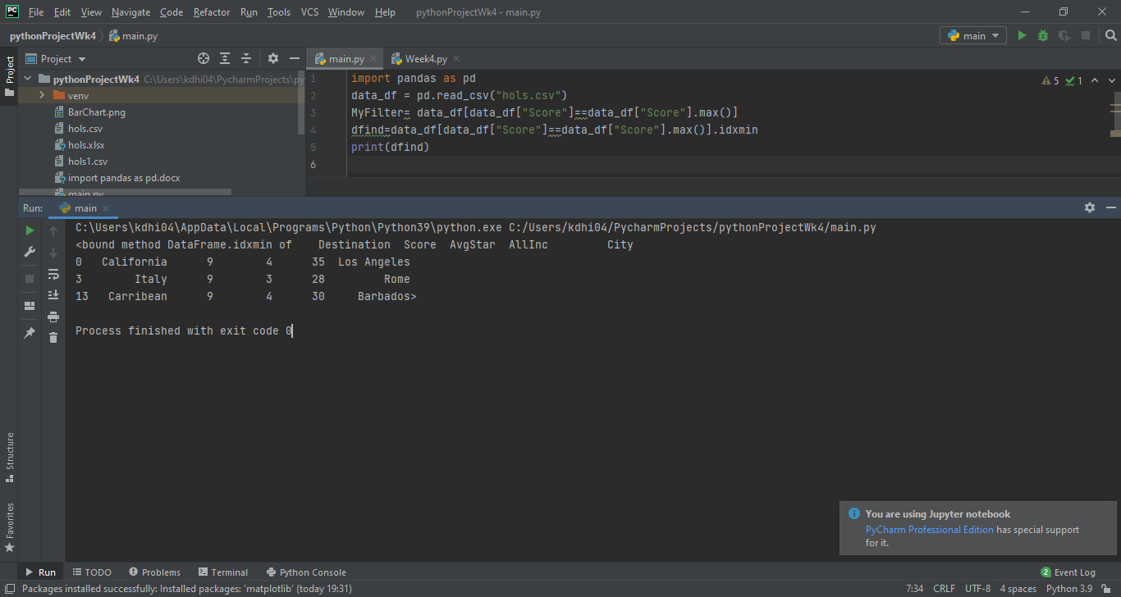

1. All destinations where there are more than 9 all-inclusive hotels (13 out of 15 hotels)

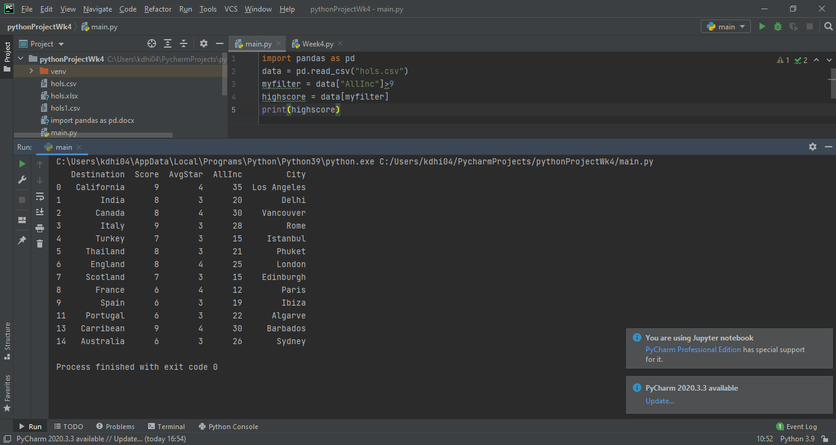

1. Filter data by destination and score above 8

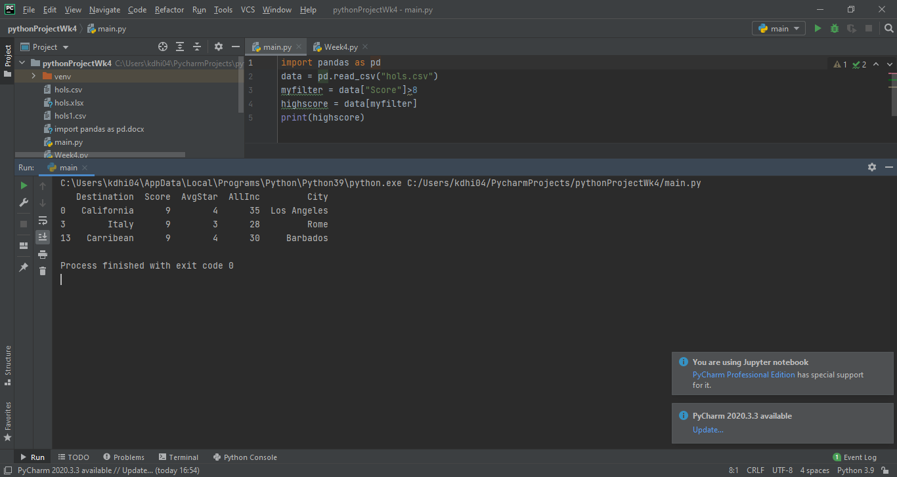

1. Filter data by destination and score below 2

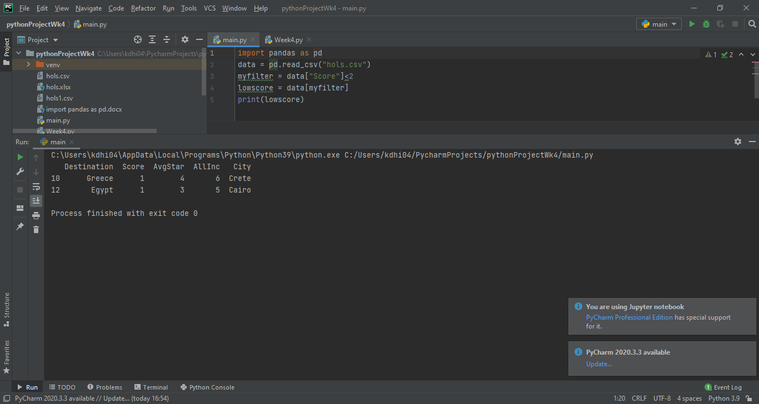

1. Is there a correlation between number of all-inclusive hotels and score?

Yes there is a correlation as both hotels with the lowest score also have the lowest number of all-inclusive hotels.

1. Create a data visualisation diagram to show destination and highest score

